Predicate

🔹 What is Predicate
# Source: AI Source: Provided by: [Data Path: Persons Table -> ID Column: 1, Name_En Column: Motasem Essam] -> From: [Chatgpt (GPT-4-turbo)] on [8/3/2025]
The predicate is the part of a sentence or clause that says something about the subject.
It typically contains a verb and everything that follows it: objects, complements, and modifiers.
🧠 In short:
Subject = who or what the sentence is about
Predicate = what is said about the subject

✅ Structure of a Predicate:
# Source: AI Source: Provided by: [Data Path: Persons Table -> ID Column: 1, Name_En Column: Motasem Essam] -> From: [Chatgpt (GPT-4-turbo)] on [8/3/2025]
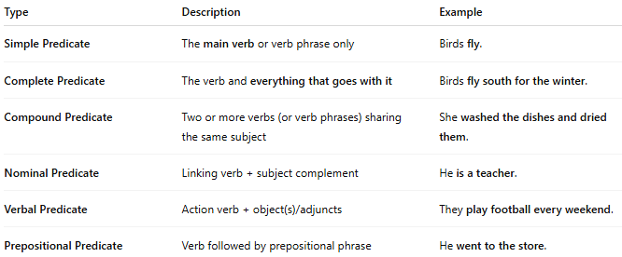
Element | Included in Predicate? | Example
Main verb | ✅ | She ran.
Objects | ✅ | She ate a sandwich.
Complements | ✅ | She is a doctor.
Modifiers (adjuncts) | ✅ | She ran quickly to the store.

✅ Types of Predicates:
# Source: AI Source: Provided by: [Data Path: Persons Table -> ID Column: 1, Name_En Column: Motasem Essam] -> From: [Chatgpt (GPT-4-turbo)] on [8/3/2025]
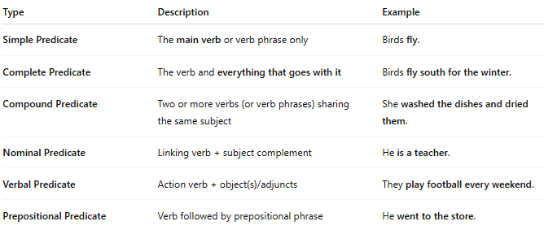
Type | Description | Example
Simple Predicate | The main verb or verb phrase only | Birds fly.
Complete Predicate | The verb and everything that goes with it | Birds fly south for the winter.
Compound Predicate | Two or more verbs (or verb phrases) sharing the same subject | She washed the dishes and dried them.
Nominal Predicate | Linking verb + subject complement | He is a teacher.
Verbal Predicate | Action verb + object(s)/adjuncts | They play football every weekend.
Prepositional Predicate | Verb followed by prepositional phrase | He went to the store.

✅ Predicate Examples by Sentence Type:
# Source: AI Source: Provided by: [Data Path: Persons Table -> ID Column: 1, Name_En Column: Motasem Essam] -> From: [Chatgpt (GPT-4-turbo)] on [8/3/2025]
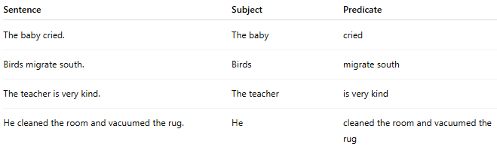
Sentence | Subject | Predicate
The baby cried. | The baby | cried
Birds migrate south. | Birds | migrate south
The teacher is very kind. | The teacher | is very kind
He cleaned the room and vacuumed the rug. | He | cleaned the room and vacuumed the rug

✅ Predicate vs. Verb Phrase:
# Source: AI Source: Provided by: [Data Path: Persons Table -> ID Column: 1, Name_En Column: Motasem Essam] -> From: [Chatgpt (GPT-4-turbo)] on [8/3/2025]
While often similar, "predicate" refers to the syntactic function, while "verb phrase" refers to the constituent structure.
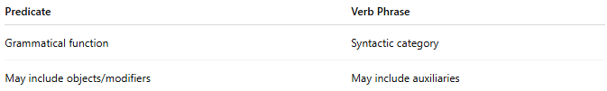
Predicate | Verb Phrase
Grammatical function | Syntactic category
May include objects/modifiers | May include auxiliaries
🔸 Example:
In “She has been reading quietly,”
- Predicate = “has been reading quietly” (function)
- Verb phrase = “has been reading” (structure)

✅ Predicate in Passive Sentences:
# Source: AI Source: Provided by: [Data Path: Persons Table -> ID Column: 1, Name_En Column: Motasem Essam] -> From: [Chatgpt (GPT-4-turbo)] on [8/3/2025]
In passive constructions, the predicate still contains the verb, but the focus shifts to the subject being acted upon.
Example:
The cake was eaten by the children.
→ Subject: The cake
→ Predicate: was eaten by the children

📝 Summary:
# Source: AI Source: Provided by: [Data Path: Persons Table -> ID Column: 1, Name_En Column: Motasem Essam] -> From: [Chatgpt (GPT-4-turbo)] on [8/3/2025]
- The predicate tells what the subject does, is, or has.
- It always includes a verb, and may also include objects, complements, or modifiers.
- Key types: simple, complete, compound, nominal, and verbal predicates.
- Understanding predicates is essential for sentence analysis and grammar parsing.

